DIS-CAN-Eskimo-Anorak-Sea Mammal Intestines, Sinew, Corn Kernels-Nootka Sound-ca 1850-1870

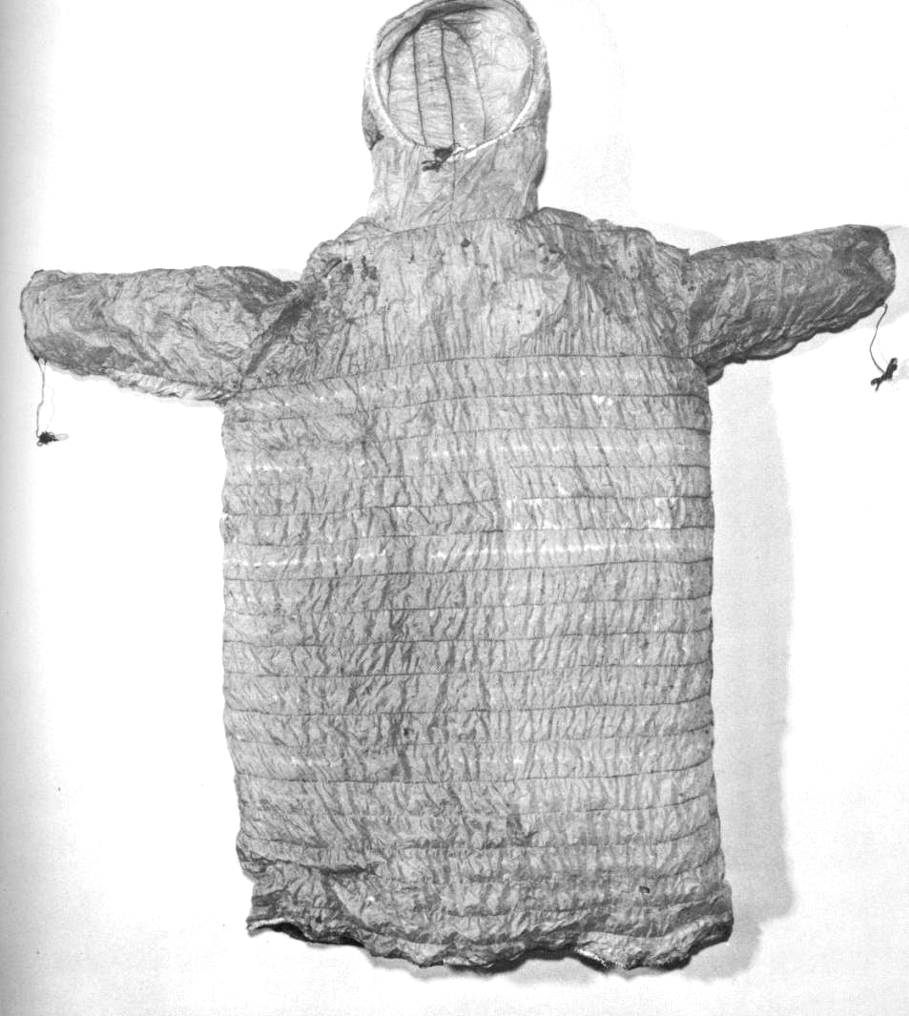

This is a gut frock made of sea mammal intestines sewn horizontally together with sinew thread and with a hood integrally sewn with the body of the frock. The two arms have wrist draw strings. Corn kernels have been attached as decorations in the horizontal sinew strands.

Case no.:

Accession Number:

Formal Label:

**Display Description:**

**LC Classification:**

Date or Time Horizon:

Geographical Area:

**Map:**

**GPS coordinates:**

Cultural Affiliation:

Media:

Dimensions:

Weight:

Condition:

Provenance:

**Discussion:**

**References:**